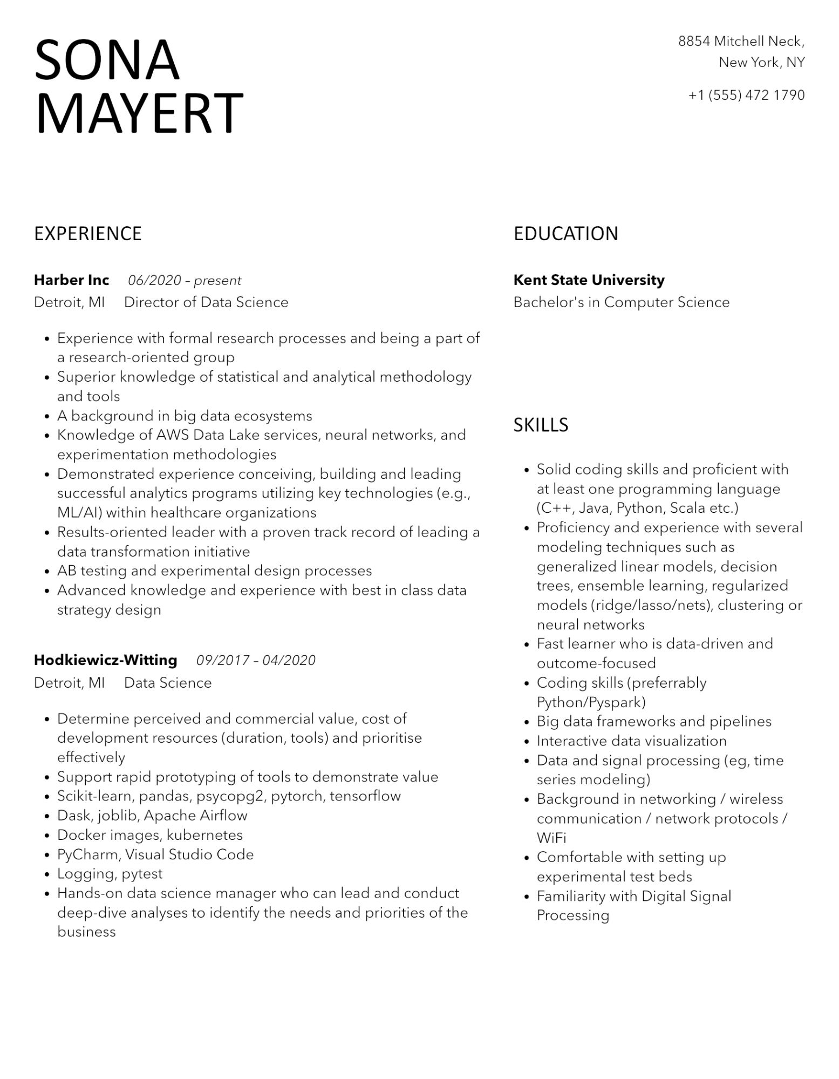
SONA MAYERT
8854 Mitchell Neck,
New York, NY
+1 (555) 472 1790
EXPERIENCE
Harber Inc
06/2020 - present
Detroit, MI
·
•
•
•
•
•
•
•
Director of Data Science
Experience with formal research processes and being a part of a research-oriented group
Superior knowledge of statistical and analytical methodology and tools
A background in big data ecosystems
Knowledge of AWS Data Lake services, neural networks, and experimentation methodologies
Demonstrated experience conceiving, building and leading successful analytics programs utilizing key technologies (e.g., ML/AI) within healthcare organizations
Results-oriented leader with a proven track record of leading a data transformation initiative
AB testing and experimental design processes
Advanced knowledge and experience with best in class data strategy design
Hodkiewicz-Witting
Detroit, MI
•
•
·
09/2017-04/2020
Data Science
Determine perceived and commercial value, cost of development resources (duration, tools) and prioritise effectively
Support rapid prototyping of tools to demonstrate value Scikit-learn, pandas, psycopg2, pytorch, tensorflow
•
Dask, joblib, Apache Airflow
•
Docker images, kubernetes
•
PyCharm, Visual Studio Code
•
Logging, pytest
Hands-on data science manager who can lead and conduct deep-dive analyses to identify the needs and priorities of the business
EDUCATION
Kent State University
Bachelor's in Computer Science
SKILLS
• Solid coding skills and proficient with at least one programming language (C++, Java, Python, Scala etc.) Proficiency and experience with several modeling techniques such as generalized linear models, decision trees, ensemble learning, regularized models (ridge/lasso/nets), clustering or neural networks
•
•
Fast learner who is data-driven and outcome-focused
Coding skills (preferrably Python/Pyspark)
Big data frameworks and pipelines
• Interactive data visualization
• Data and signal processing (eg, time series modeling)
Background in networking / wireless communication / network protocols/
WiFi
• Comfortable with setting up experimental test beds
Familiarity with Digital Signal Processing

